

**“MICRO CREDIT DEFAULTER PROJECT”**

**Submitted by:**

**SUJIT KUMAR**

**ACKNOWLEDGEMENT**

The internship opportunity I have with Flip Robo Technologies is a great chance for learning and professional development. I perceive this opportunity as a big milestone in my career development. I will strive to use gained skills acknowledge in the best possible way.

I would like to extend my appreciation and thanks for the mentors from DataTrained and professionals from FlipRoboTechnologies who had extended their help and support.

**References:**

https://www.geeksforgeeks.org/machine-learning**/**

<https://sklearn.org/supervised_learning.html#supervised-learning>

<https://www.datacamp.com/community>

<https://github.com/mxc19912008/Andrew-Ng-Machine-Learning-Notes>

<https://www.analyticsvidhya.com/blog/category/machine-learning/>

**INTRODUCTION**

**Business Problem:**

A client in Telecom Industry is collaborating with an MFI (Microfinance Institution) to provide micro-credit on mobile balances to be paid back in 5 days. The Consumer is believed to be defaulter if he deviates from the path of paying back the loaned amount within the time duration of 5 days.

In order to improve the selection of customers for the credit, the client wants some predictions that could help them in further investment and improvement in selection of customers.

**Background of domain:**

* Microfinance is a banking service provided to unemployed or low-income individuals or groups who otherwise would have no other access to financial services.
* Microfinance allows people to take on reasonable small business loans safely, and in a manner that is consistent with ethical lending practices.
* The majority of microfinancing operations occur in developing nations, such as Uganda, Indonesia, Serbia, and Honduras.
* Like conventional lenders, microfinanciers charge interest on loans and institute specific repayment plans.
* The World Bank estimates that more than 500 million people have benefited from microfinance-related operations.

Indonesia is renowned for its large scale microfinance sector, with a range of commercial banks. More than 56.5 million Micro Small Medium Enterprises1 (MSME), contributed greater than 50% of Gross Domestic Product (GDP) in 2014. However, many of them do not have adequateacces to the bank financing they need to grow their businesses, particularly in rural areas.

Some rural communities in Indonesia have no choice but to seek out loans from unregulated money lenders. Micro lenders, particularly those operating under Indonesian banks, as well as social enterprise startups, are also targeting these communities through their high mobile penetration rates and are developing the right digital platforms to reach out to them.

Only around 22% of Indonesians are connected to formal financial institutions.

Micro-finance is accessible for people in remote areas and on small islands, not just people in the cities.

In 2012, there were 143 million unique mobile subscribers, more than double the number of bank account holders (62 million). Telecommunication operators have more than 300,000 locations at which phone vouchers are sold. Most banks would like to have access to these distribution networks, which would enable them to access the poorest people requiring micro-finance.

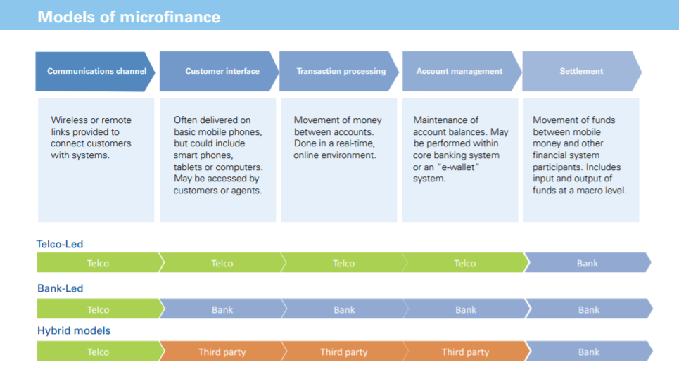

**MOTIVATION FOR PROBLEM UNDER TAKEN:**

Based on data provided from our client database, customer’s repayment of loan is assessed based on different factors. By building the model, we can assess which customers are highly likely to repay the loan, thereby it will be useful for those needy people who will repay the loan and also prevent the loss to the customer by avoiding loans to the defaulters.

**ANALYTICAL PROBLEM FRAMING**

**MATHEMATICAL MODELLING OF PROBLEM:**

**Mathematical modeling is simply the method of implementing statistical analysis to a dataset where a Statistical Model is a mathematical representation of observed data.**

While analyzing the data, there are an array of statistical models we can choose to utilize.

For the given project, we need to predict whether the customer is a defaulter or not.

This is a classification problem. There are wide varieties of classification models like decision trees, random forests, nearest neighbor, Logistic Regression.

**DATA SOURCE AND FORMAT:**

The data has been provided by client in a comma separated values(.csv) format.

1. The data will be loaded into pandas dataframe.

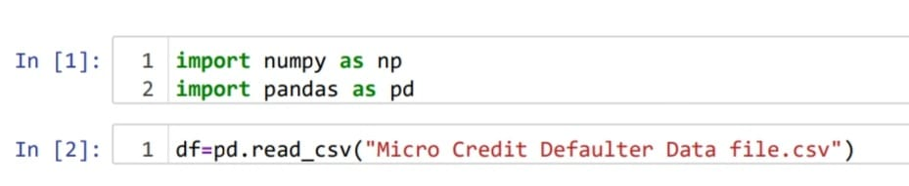

1. Checking no. of rows and columns of the data frame and the data type of columns.

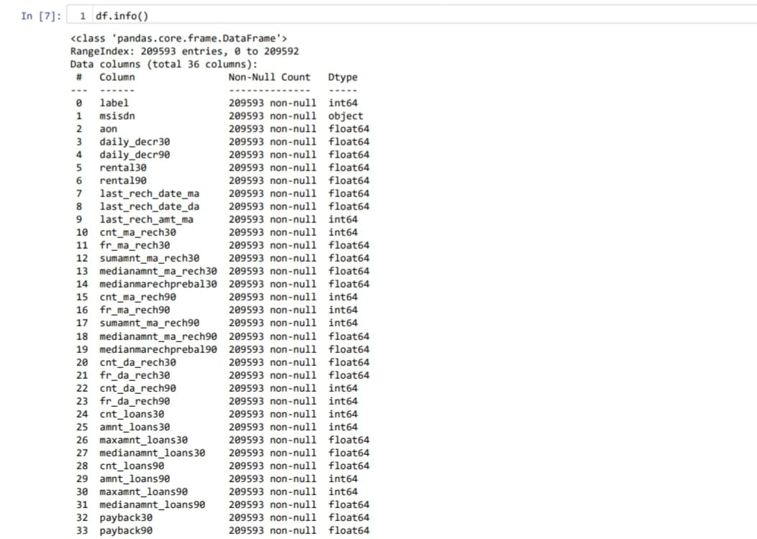

This data set has around 2 lakh rows and 36 columns.

There are 3 object columns namely msisdn,pcircle,pdate.

Msisdn is the mobile number of customer, Pcircle is the telecom circle and pdate is the date.

**DATA PRE PROCESSING:**

Data preprocessing is a technique of converting raw data into useful format.

Data cleaning is a part of preprocessing technique which involves filling missing values.

For the given dataset it has been mentioned that there are no null values.

Firstly, I dealt with object type columns.

Checking what columns are of object type and what type of data is stored in them. 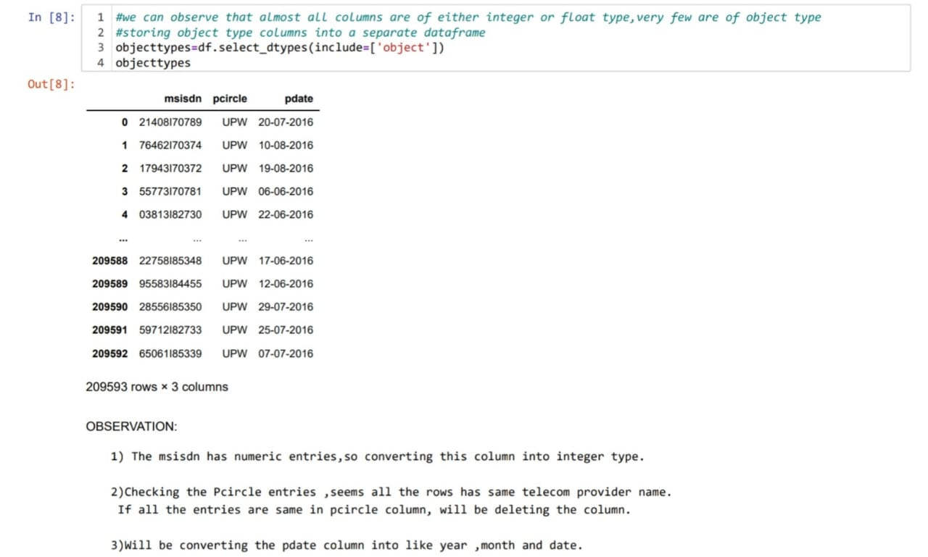

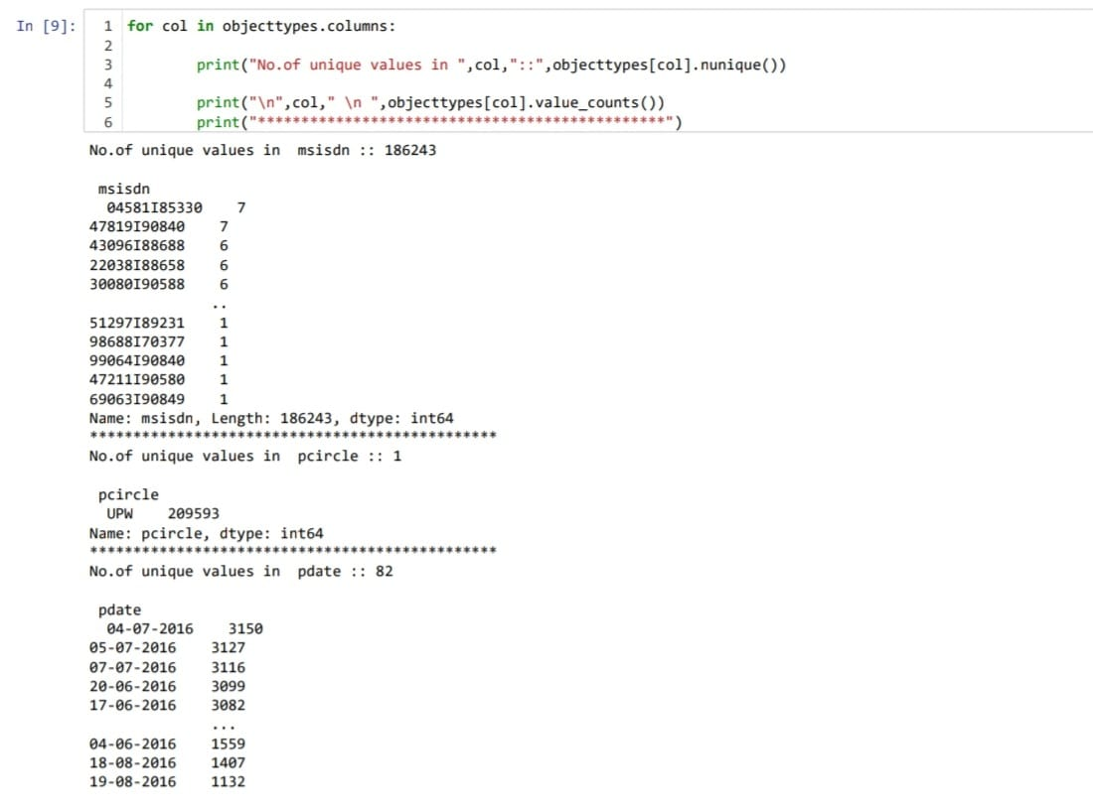

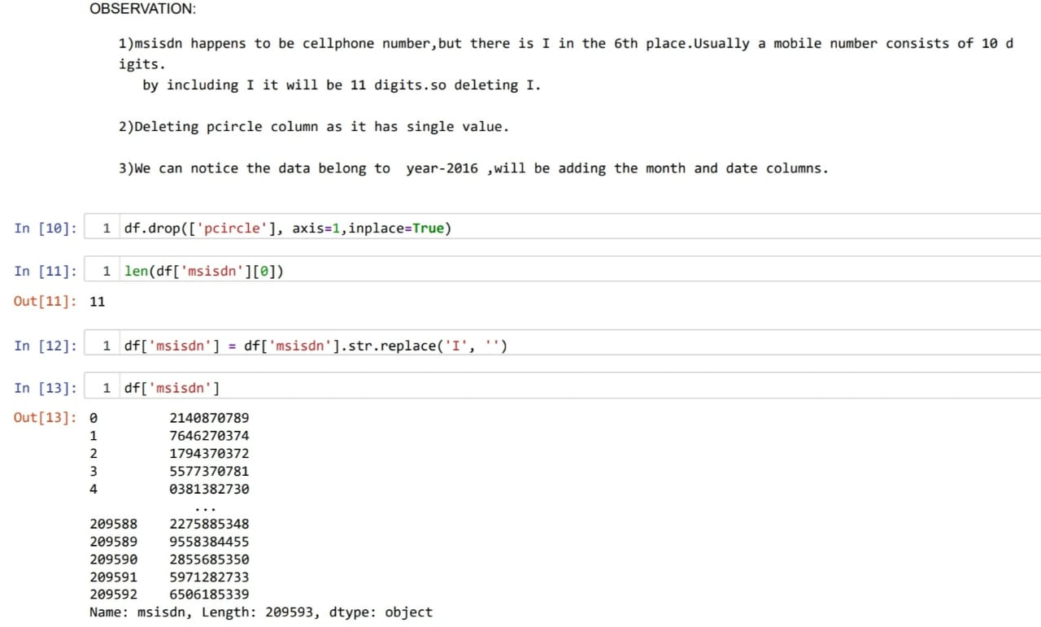

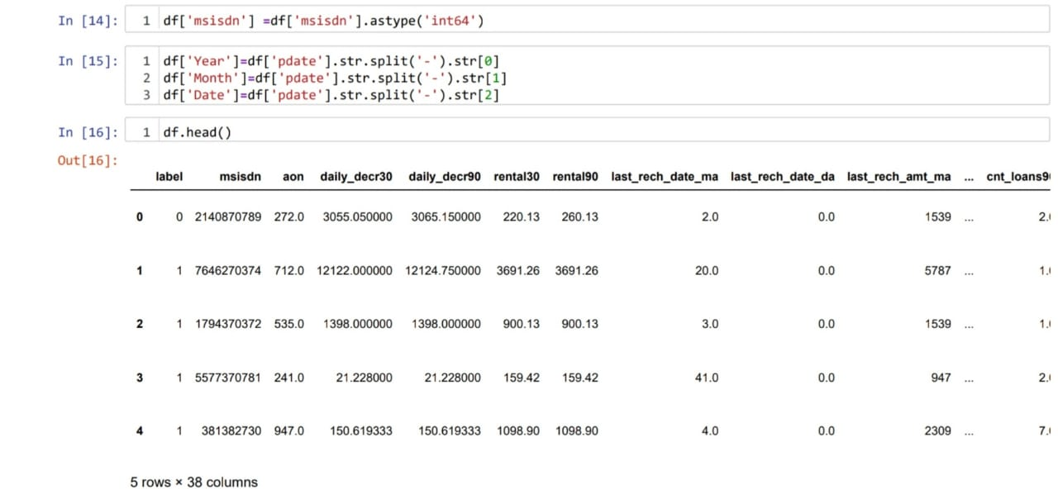

As the date column is splitted into 3 columns,will be deleting the pdate column.

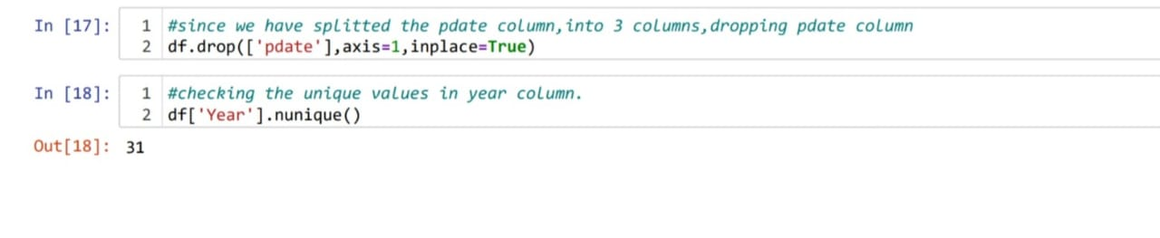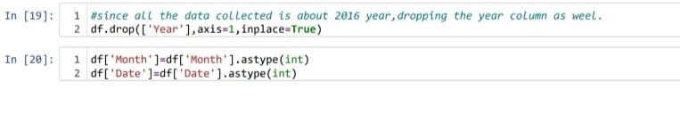Also, the data gathered belongs to 2016 year ,hence it won’t be impacting the output due to same entry in all the columns.So dropped the year column.

Later converted the month and date columns to integer.

Checking whether all the columns are of integer type.

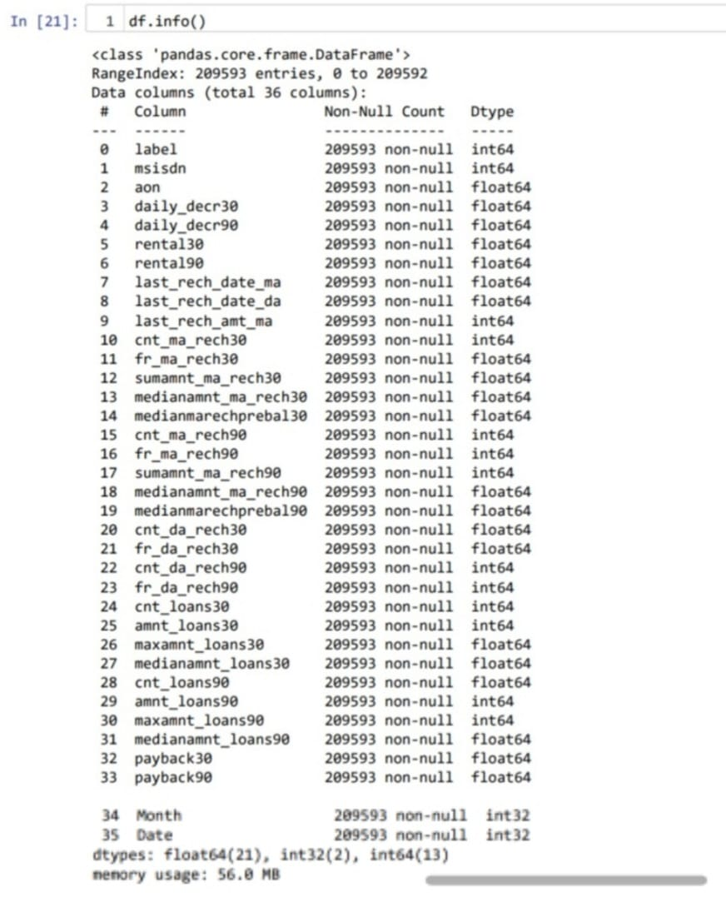

We can see that all the columns are of numeric type.

Describe method is used to view some basic statistical details like percentile, mean, standard deviation etc. of a data frame or a series of numeric values.

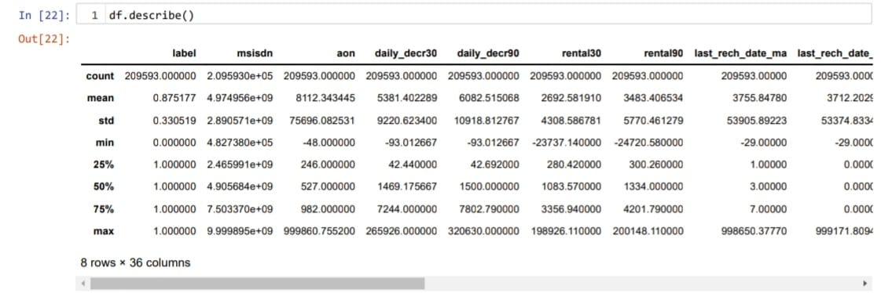

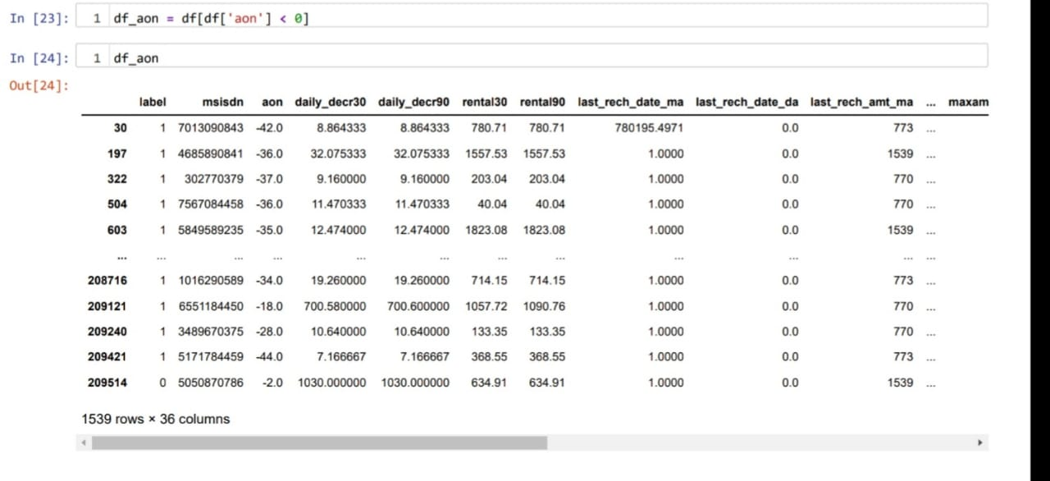

We can note that there is a huge difference in 75% value and max value for most of the columns which indicate presence of outliers.

COLUMNS WITH NEGATIVE MINIMUM VALUES:

1)aon

2)daily_decr30=>Daily amount spent from main account, averaged over last 30 days (in Indonesian Rupiah)

3)daily_decr90=>Daily amount spent from main account, averaged over last 90 days (in Indonesian Rupiah)

4)rental30=>Average main account balance over last 30 days

5)rental90=>Average main account balance over last 90 days

6)last_rech_date_ma=>Number of days till last recharge of main account

7)last_rech_date_da=>Number of days till last recharge of data account

AON:

This column predicts age on cellular network in days.

This columns minimum value should be zero, instead there are negative values might be due to typos.

so checking the other columns values where aon has negative values.



Converting the aon column to positive.

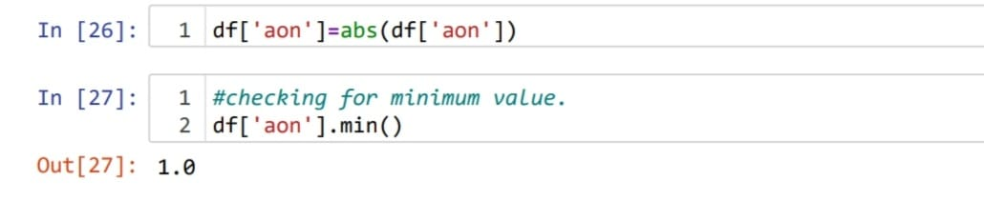

last_rech_date_ma,last_rech_date_da : these two columns indicate no.of days till last recharge of main and data accounts. This count of days also can’t be negative.

Converting them to positive.

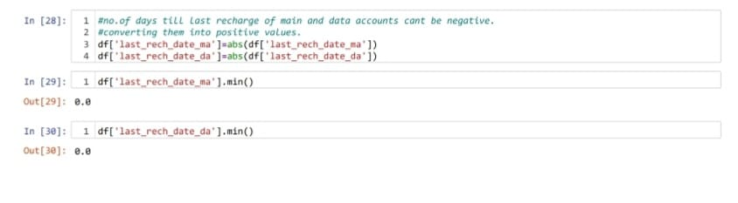

I Created two different dataframesin respect to negative values in rental 30 column.

1)One being the people who failed to repay the loan.

2)Other being the people who did repay the loan .

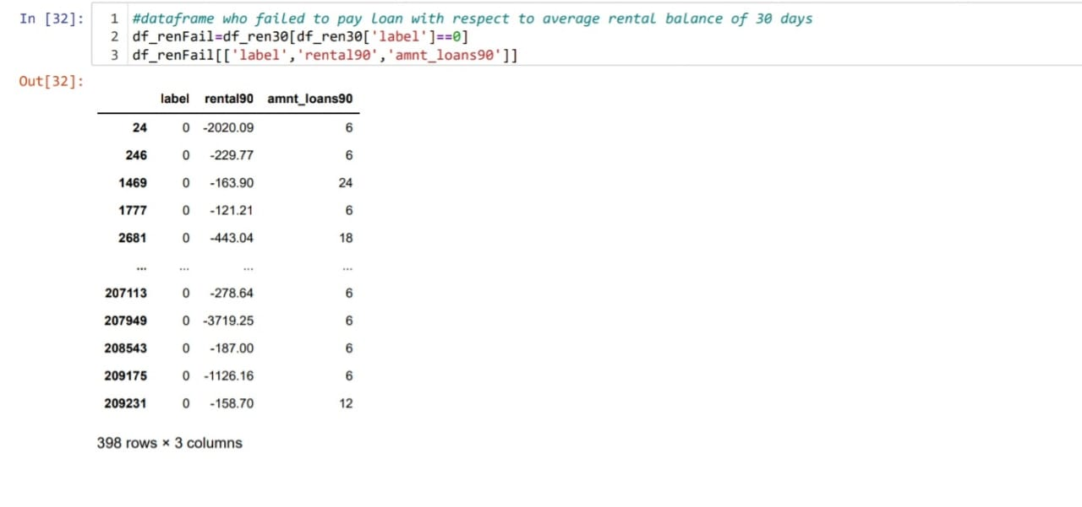

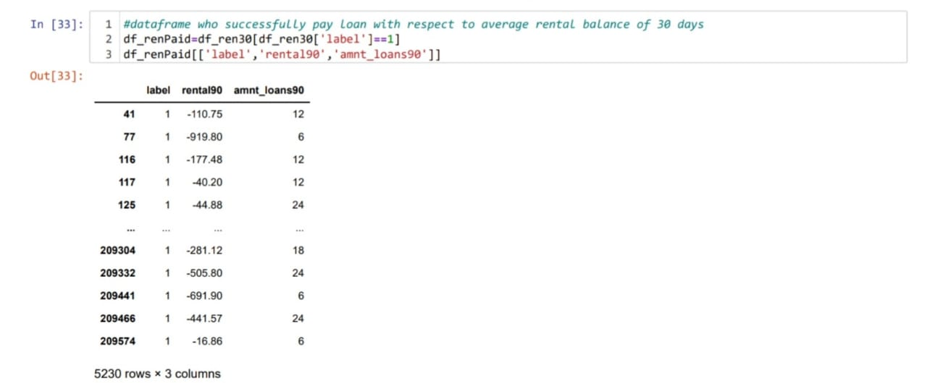

We can note that eventhough the average rental balance is in negatives which means the customer owe rent to company,

Even then they did repay their loans,which is most unlikely.

There might be other possibility that user will not be granted loan if they have negative balance. This might be due to erroneous entry.So converting them to positive.

The same approach has been followed for rental 90 column.

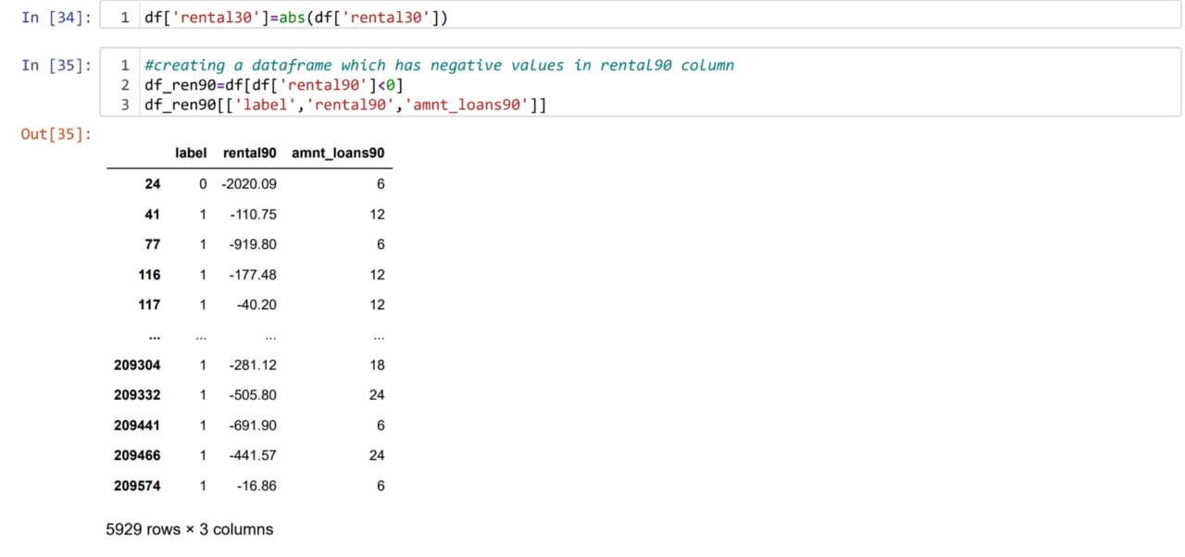

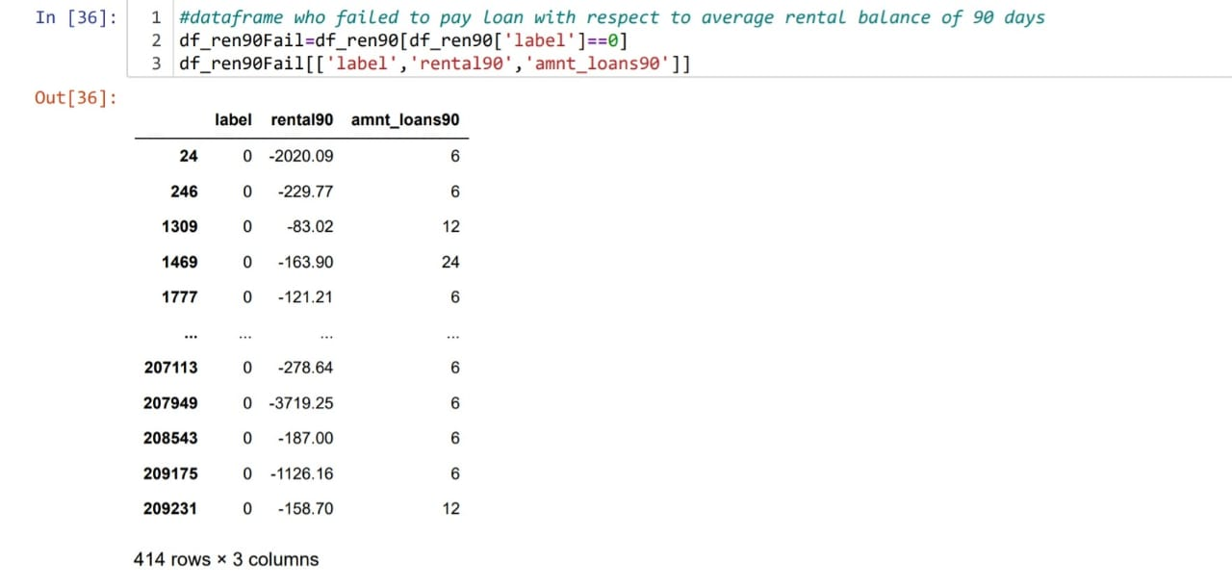

Converting the rental 90 column negative values to positive values.

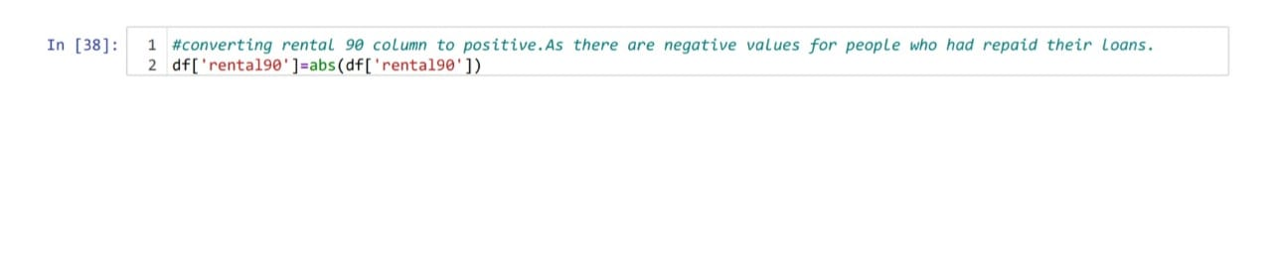Checking the entries of maxamnt_loans30 column.

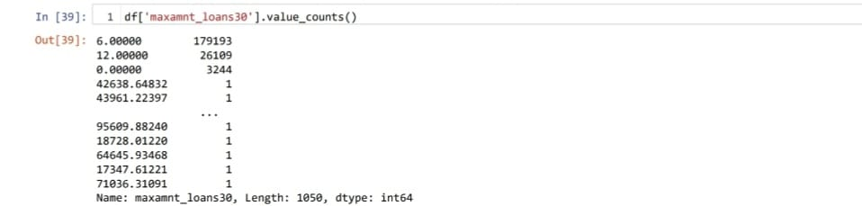

It has been mentioned that this columns values has to be either 6 or 12.we can notice that there are huge no.of entries other than 6,12. Ignoring 0 because there might be users who hasn’t taken loans.Converting the other numbers to zero beacuse there is no probability of loan repay amount other than 6 ad 12.There are 1047 rows that has values other than 6,12 and0.

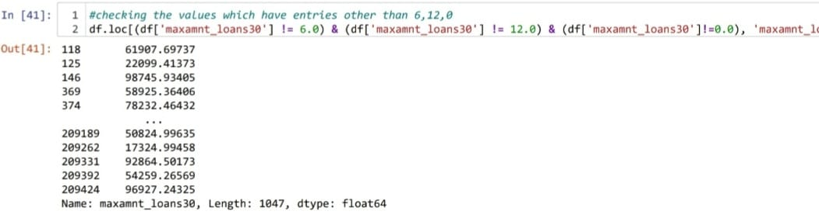

There are 1047 records of values that are other than 6,12 and 0.

Converting these 1047 records to zero because we can’t predict their repayment amount.

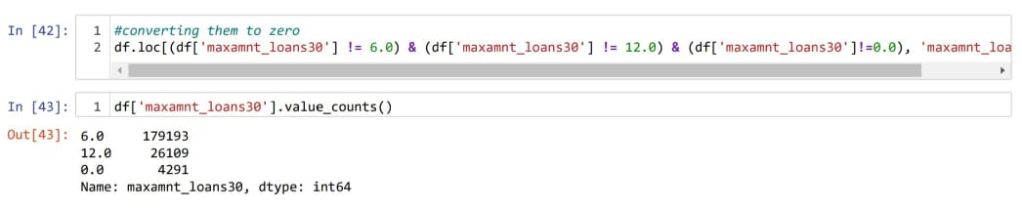

Checking the users who haven’t taken any loan.

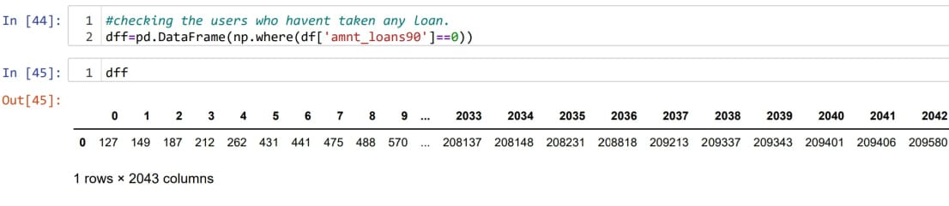

Amt_loans90 column describes the total amount of loans taken by the user in span of 90 days. The presence of zero in this column indicates that the user hasn’t taken any loans.

There are 2043 rows in the dataframe with zero in amt_loans90 column.Dropping the rows which has zero in the amt_loans 90 column because such rows wont be useful in predicting the loan repayment.

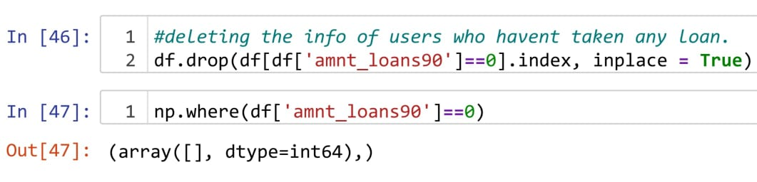

msisdn is nothing but phone number of the user,it has nothing to do with the predictions of loan payment. Hence dropping it.

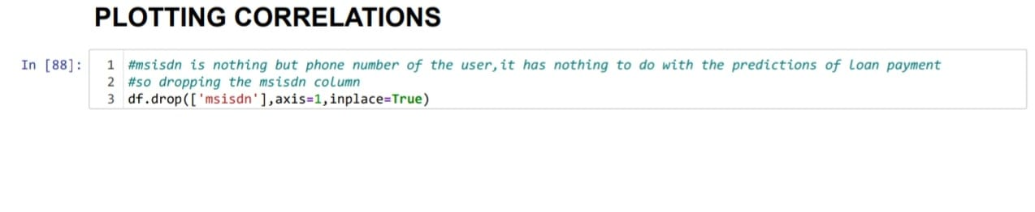

**Hardware and Softwares Used:**

Software requirement: Anaconda,Jupyter notebook

Libraries and packages used: Numpy,Pandas, Sklearn,seaborn,Matplotlib,imblearn,scipy.

**Model/s Development and Evaluation**

**Problem-solving approach:**

The data set is imbalanced since it has large no. of records which contains data about those repaid the loan and less no. of records of those who defaulted loan.

This might result in biased predictions. So, used imblearn library to reduce the imbalances. The imblearn library provides different approaches one is Random under sampling. In contextof this problem, RandomUnderSampling reduces the no.of records of those who paid the loan. To be precise,random under sampling deletes data from the majority class such that there will be equal no.of samples of both the classes.Hence reduces the bias.

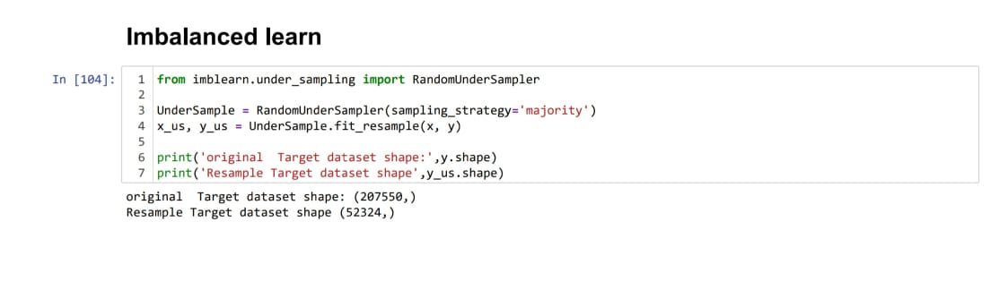

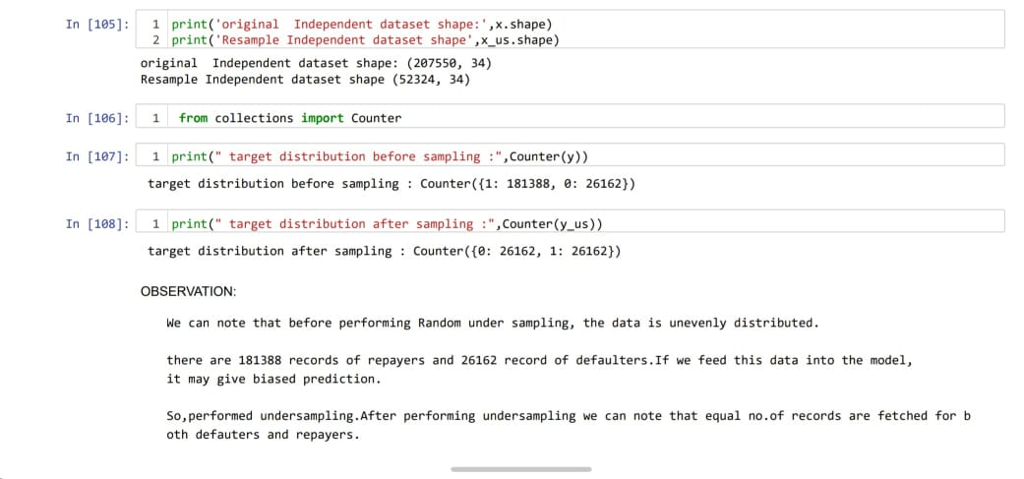

Statistical methods used:

Outlier removal : Mostly outliers are removed by either z score or IQR(Inter Quartile Range).Tried both these approaches first but, the data loss is high in both these approaches. It has been mentioned in guidelines that the data loss should not exceed 7%.So applied capping technique which is also called as winsorization.

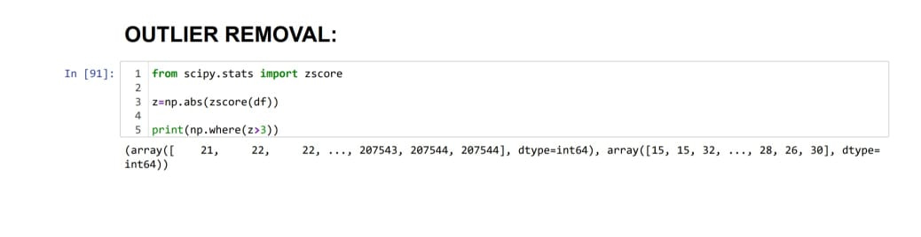

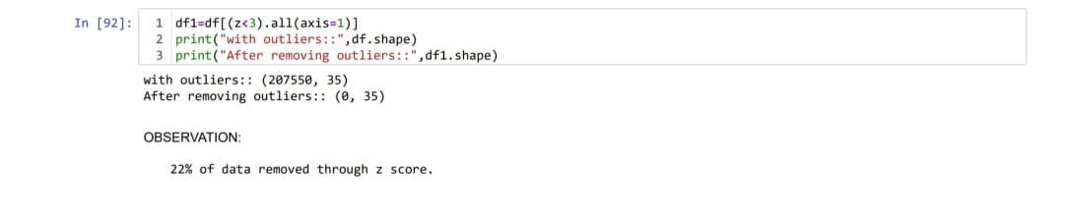

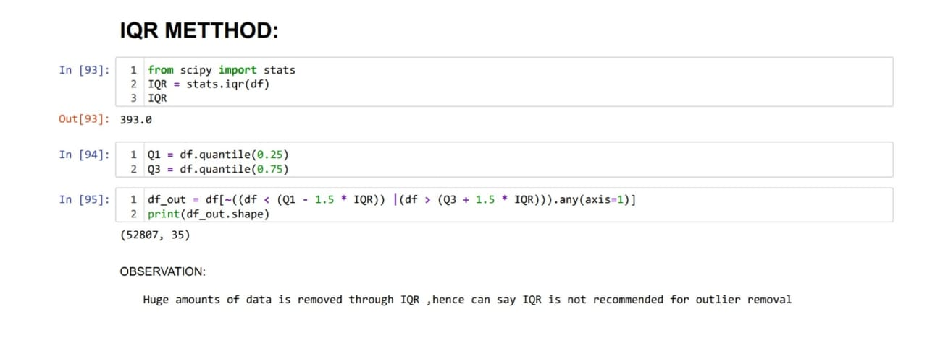

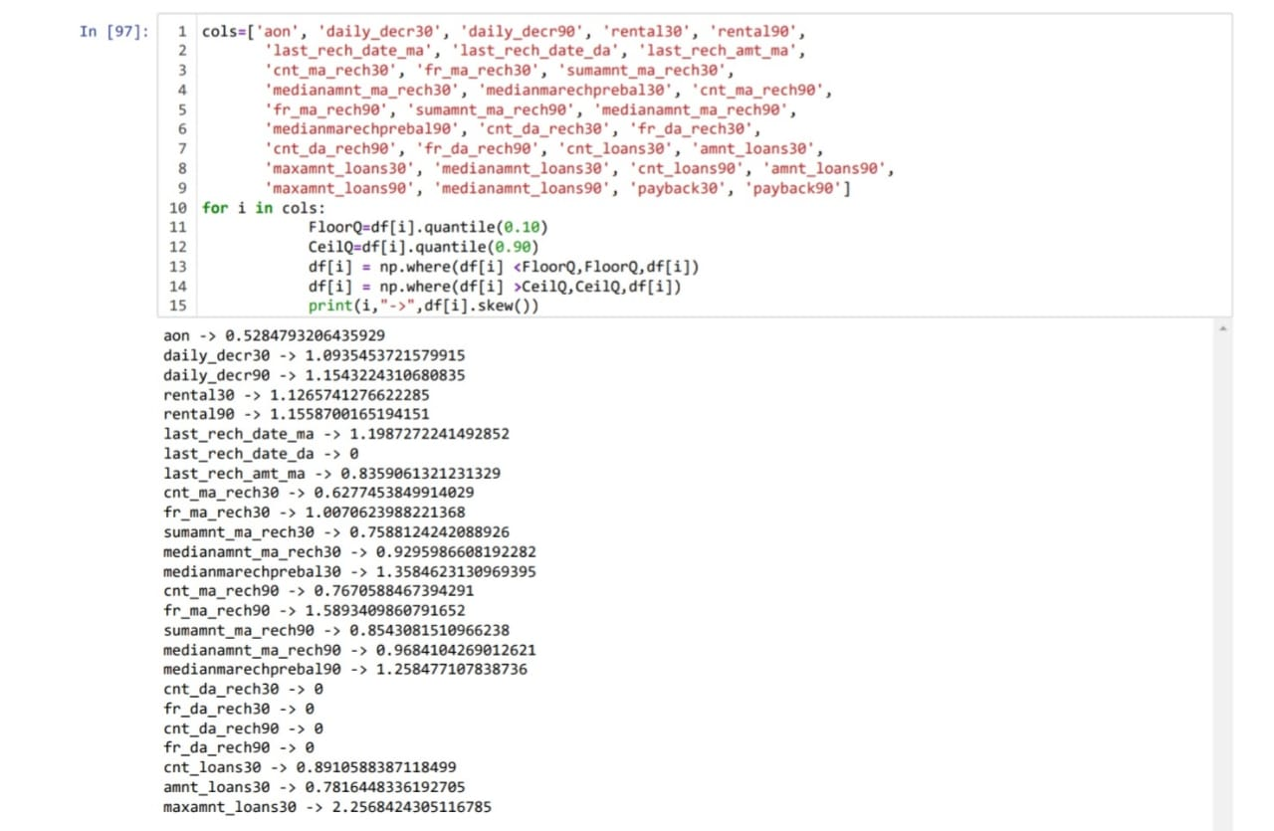

**Testing of Identified Approaches (Algorithms):**

List of algorithms used:

* Logistic Regression
* Decision Tree Classifier
* KNeighborsClassifier
* RandomForestClassifier
* AdaboostClassifier
* BaggingC;assifier
* GradientBoostingClassifier

**Run and Evaluate selected models:**

Cross-validation is used to test the model's ability to predict new data that was not used in estimating it. Cross validation used in scenarios where we need to avoid over fitting.

**LOGISTIC REGRESSION:-**

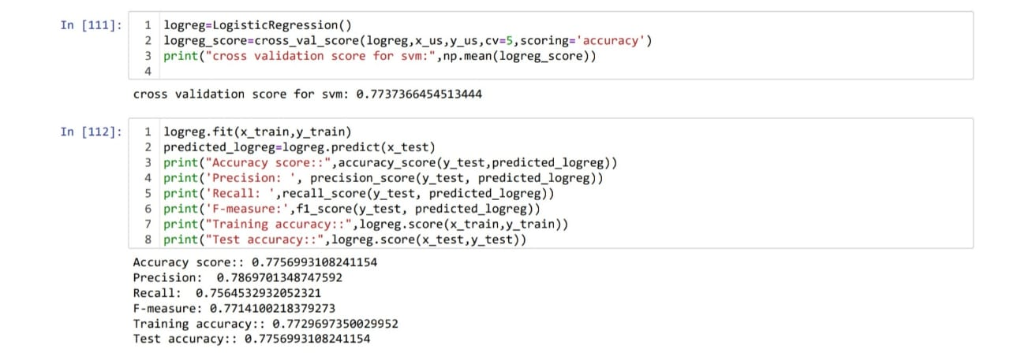

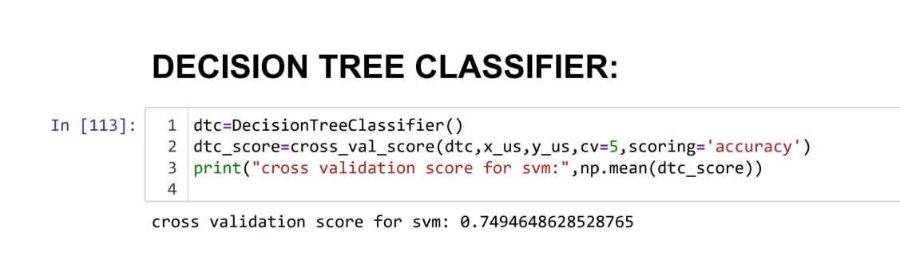

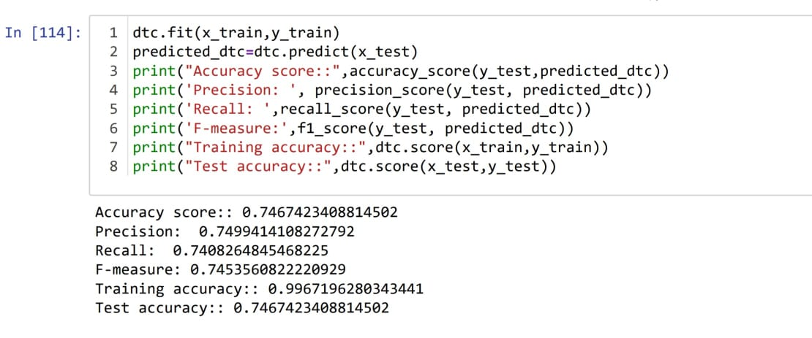

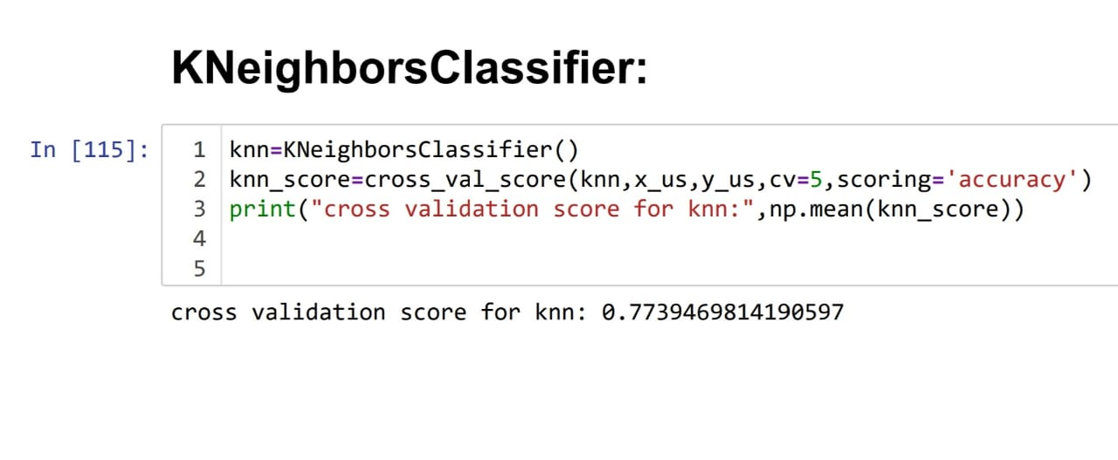 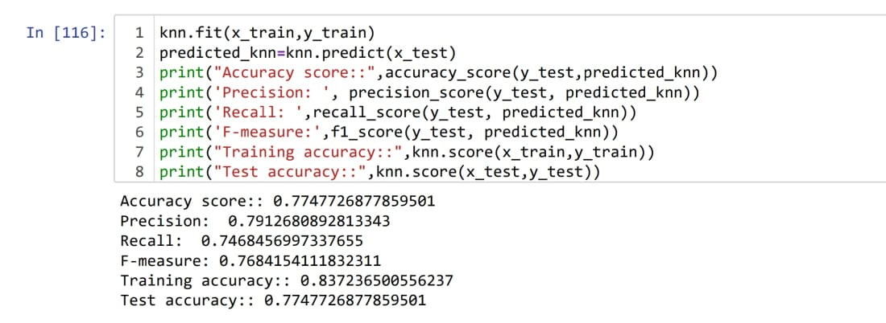

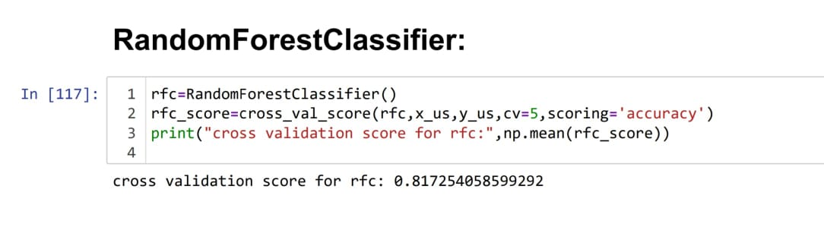

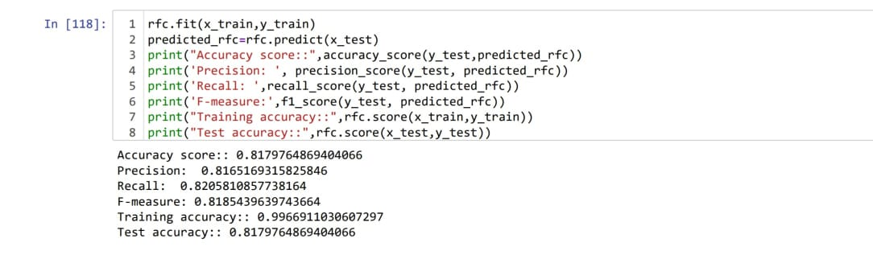

Ensemble models in machine learning operate on a similar idea. They combine the decisions from multiple models to improve the overall performance.

The idea behind bagging is combining the results of multiple models to get a generalized result.

Here I have used the following ensemble techniques.

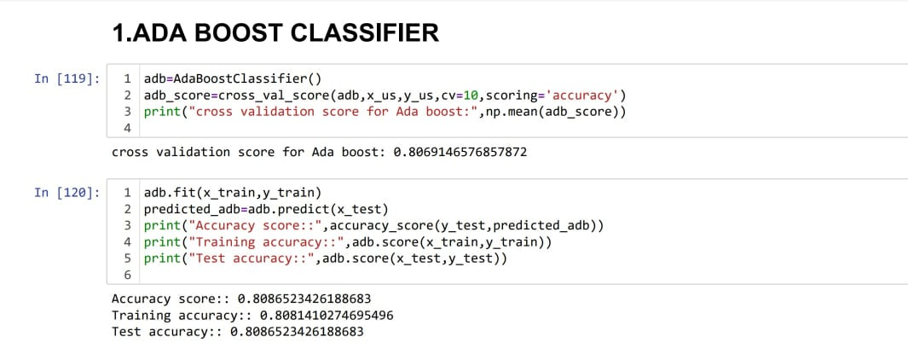

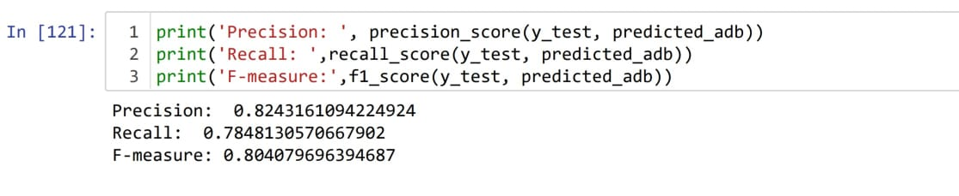

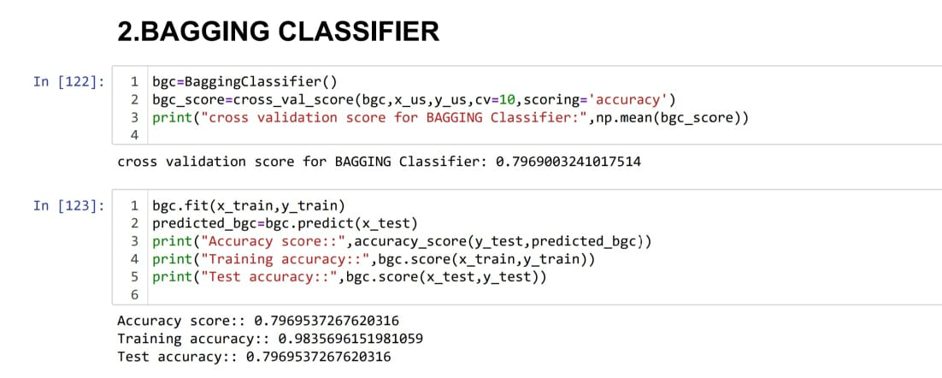

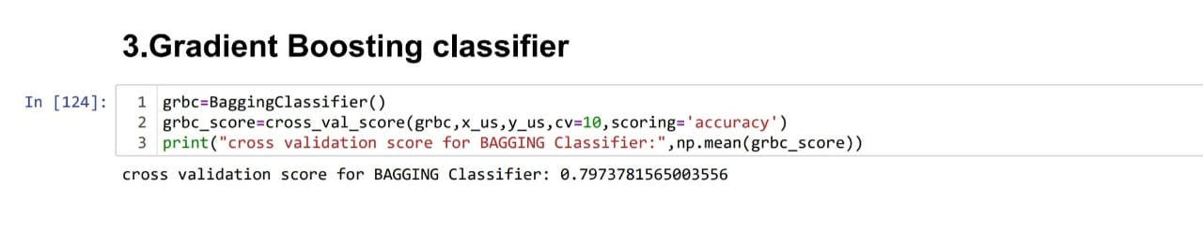

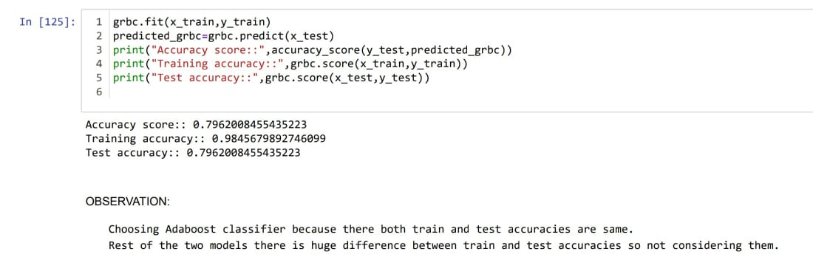

Key Metrics for success in solving problem under consideration:

A confusion matrix helps us gain an insight into how correct our predictions were and how they hold up against the actual values.

The following metrics are used :

1)Accuracy : Accuracy is the ratio of the total number of correct predictions and the total number of predictions.

2)Precision:Precision is the ratio between the True Positives and all the Positives

3)Recall:The recall is the measure of our model correctly identifying True Positive

4)F1 score:F1 Score is needed when you want to seek a balance between Precision and Recall.

HYPER PARAMETER TUNING:

Hyper parameter tuning is used to increase the performance of the algorithm.

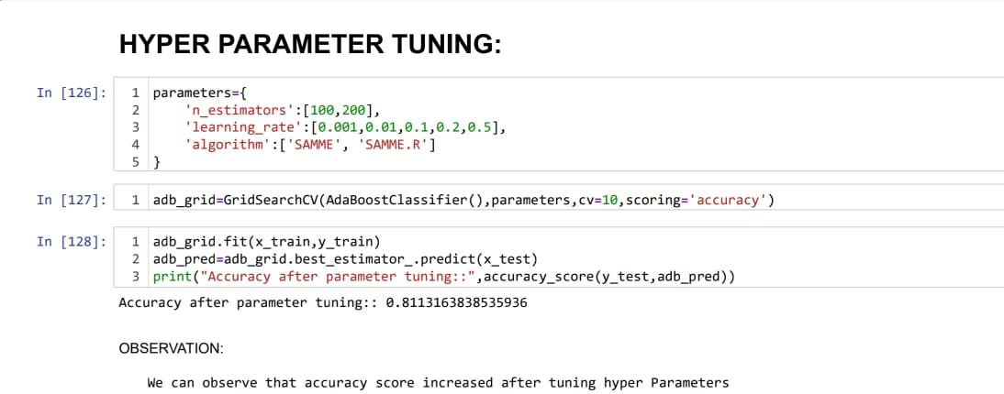

**Visualizations:**

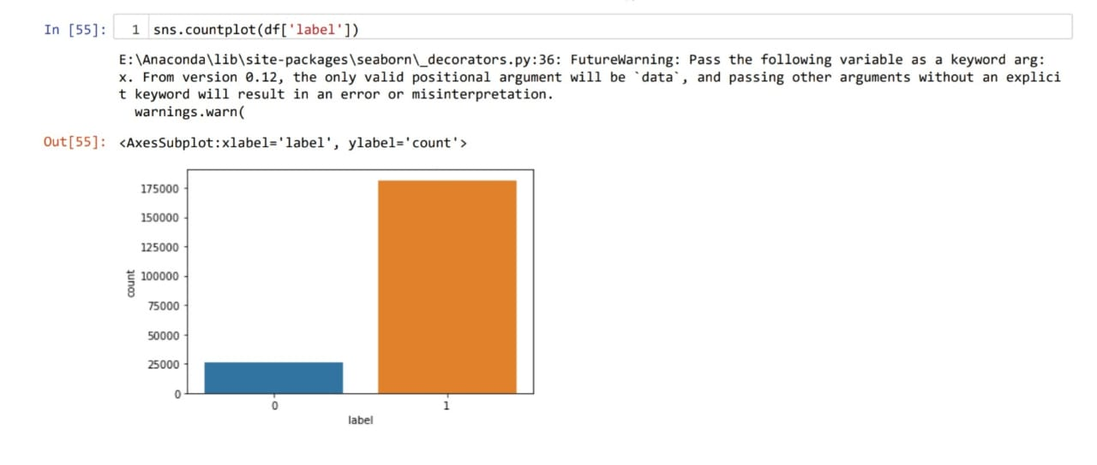

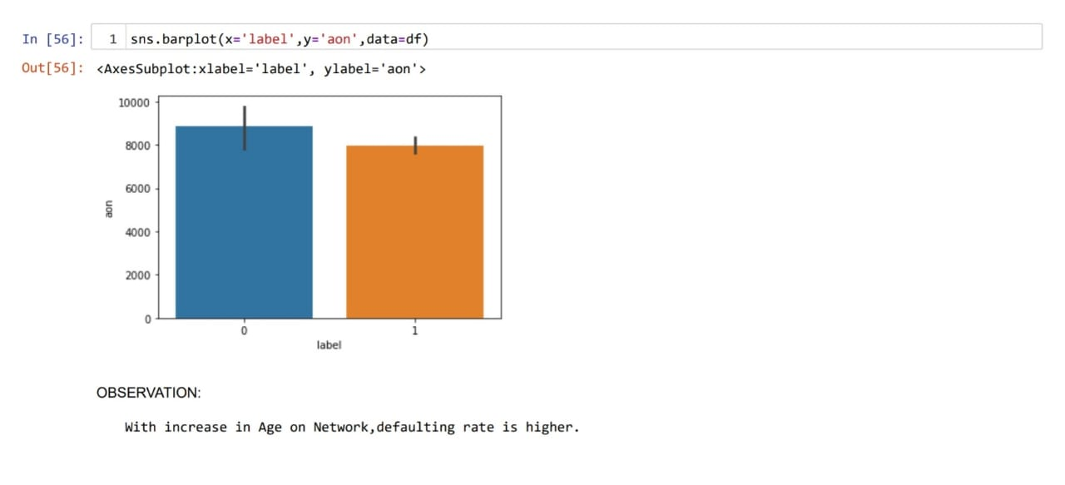

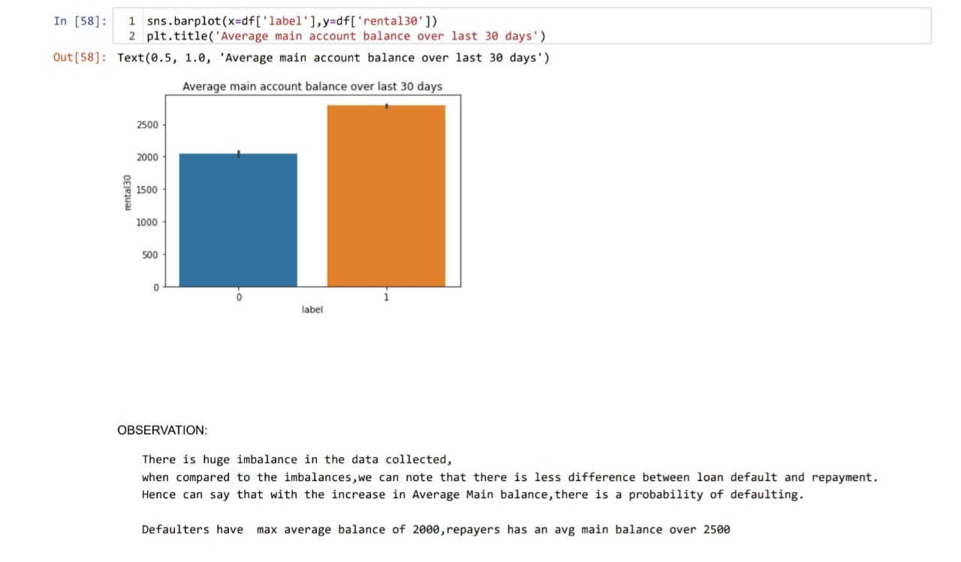

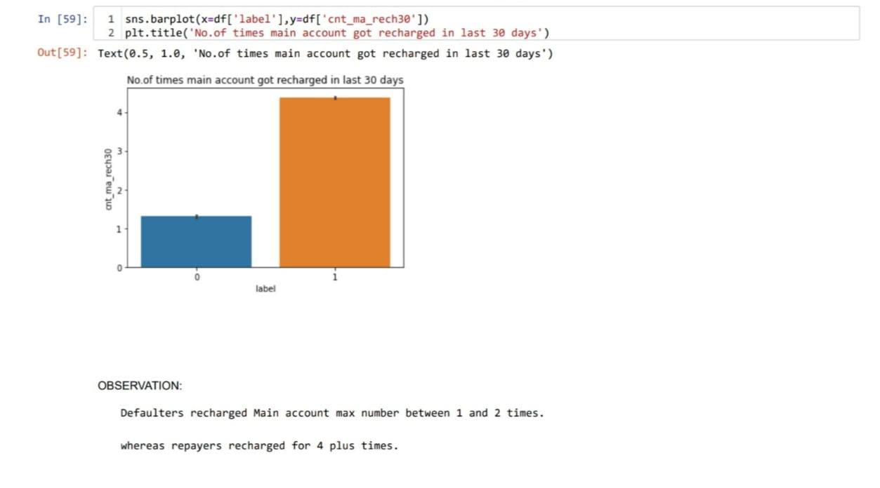

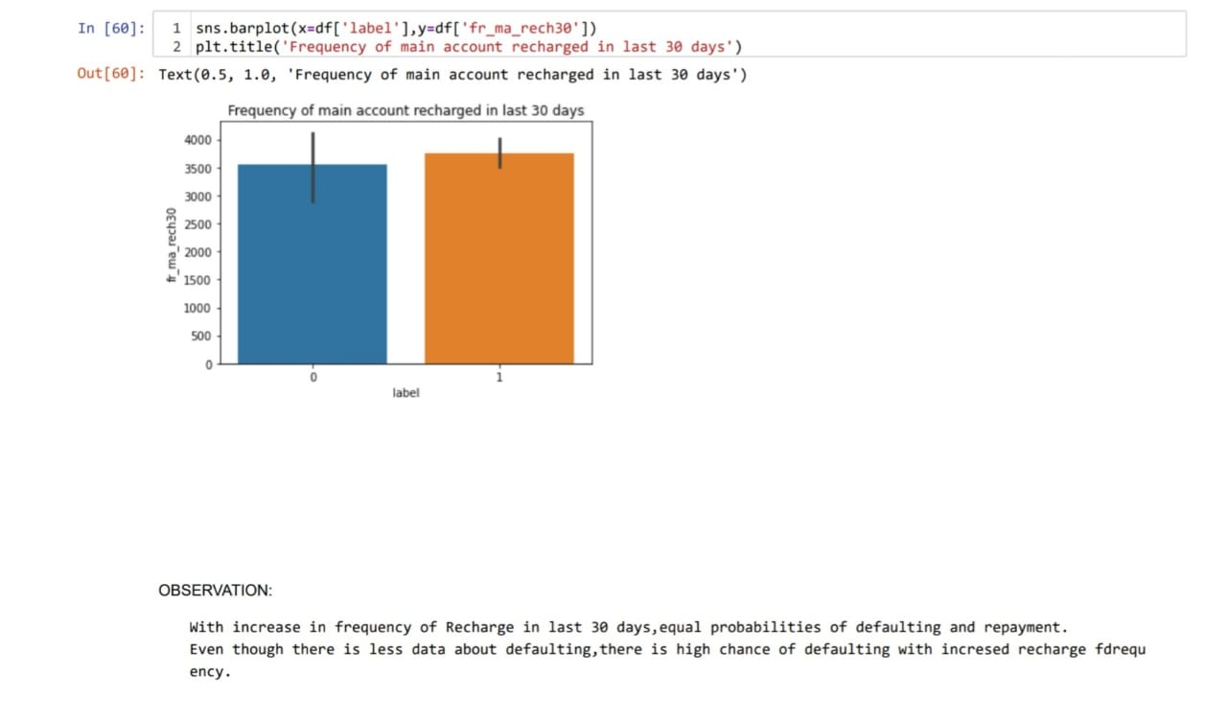

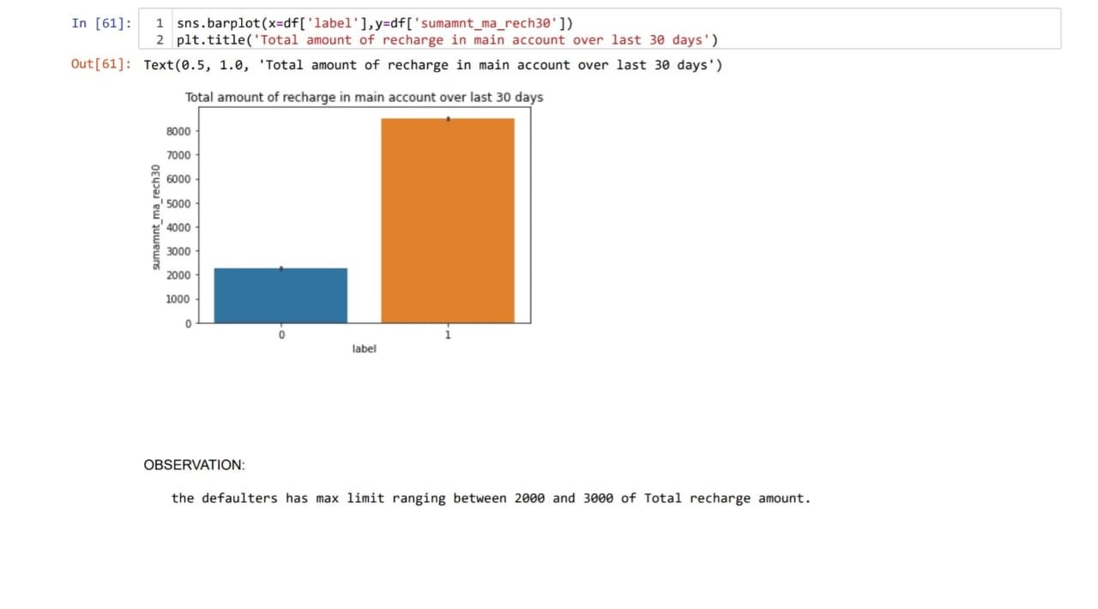

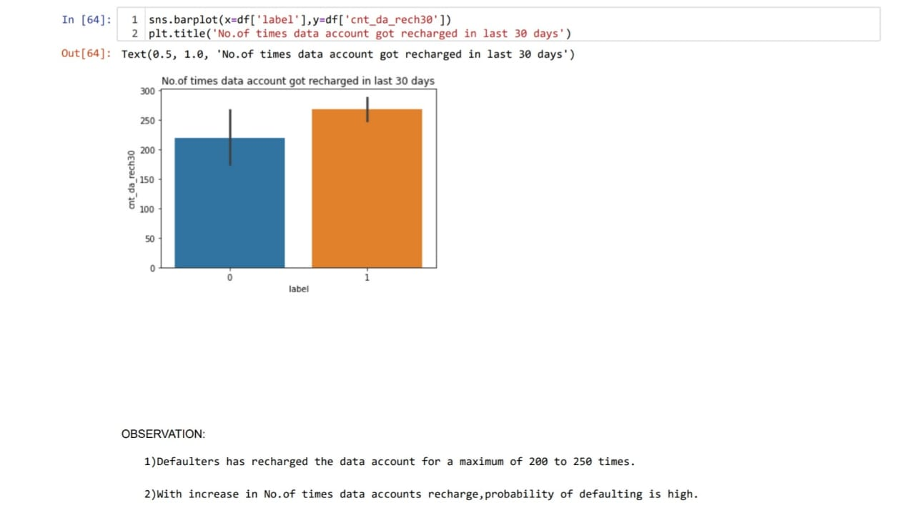

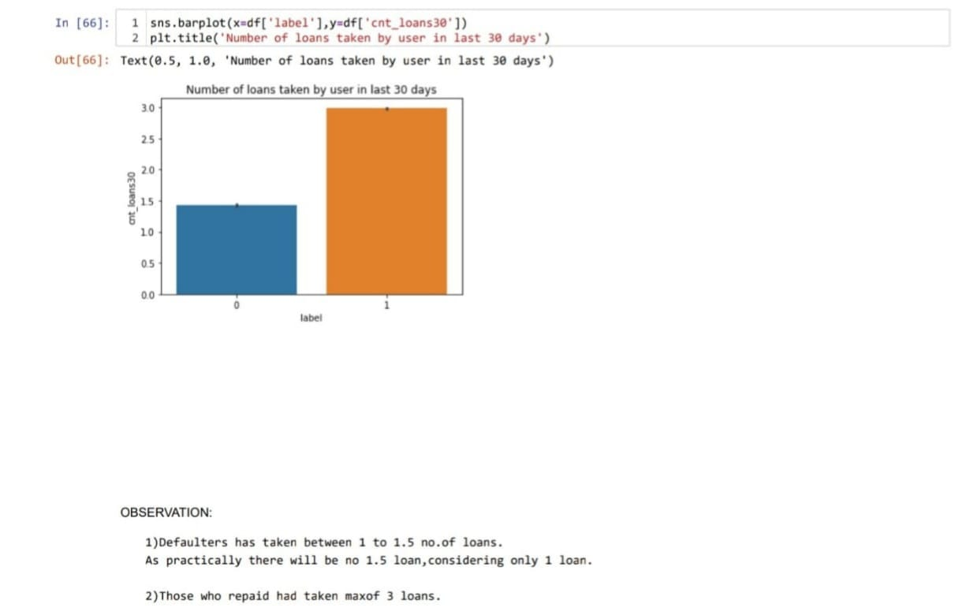

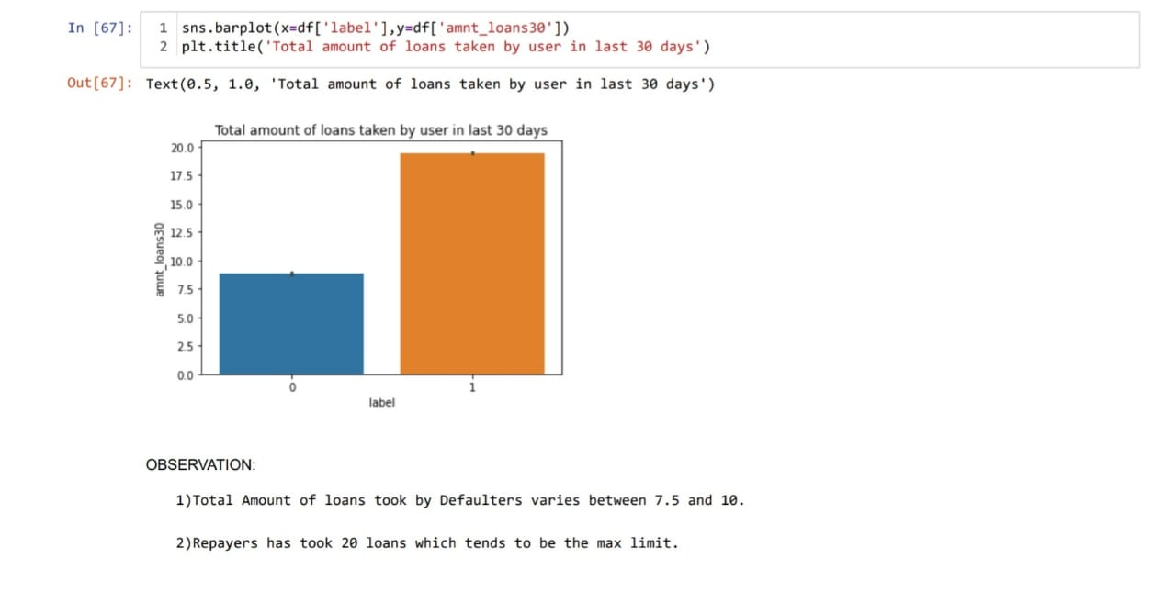

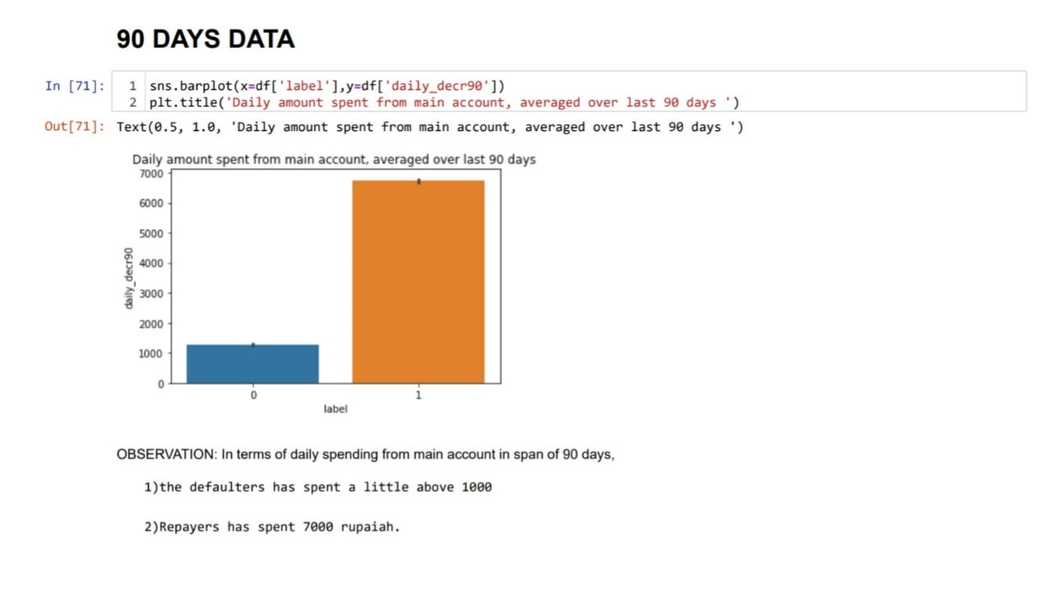

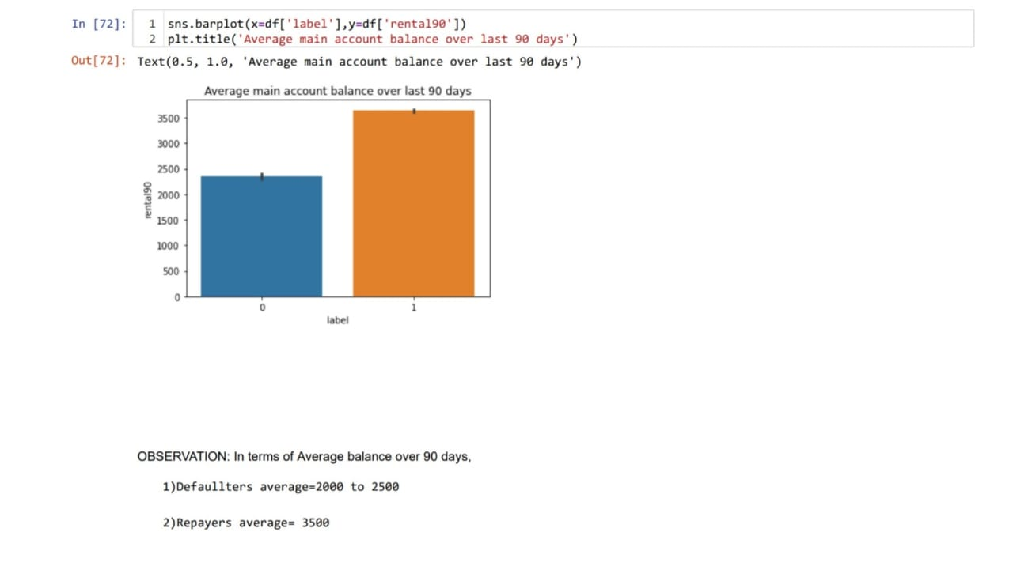

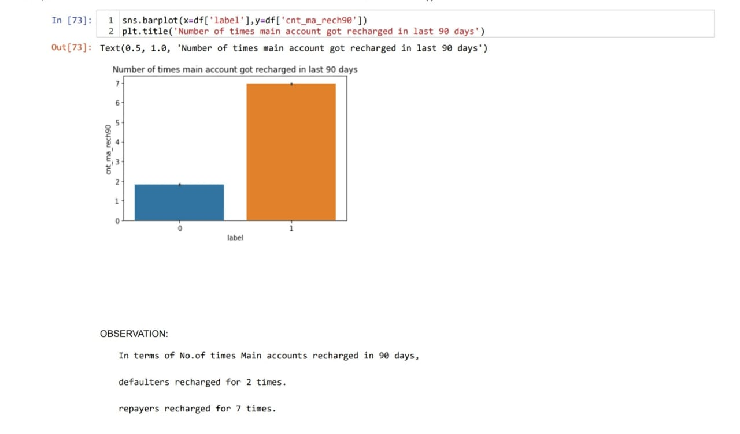

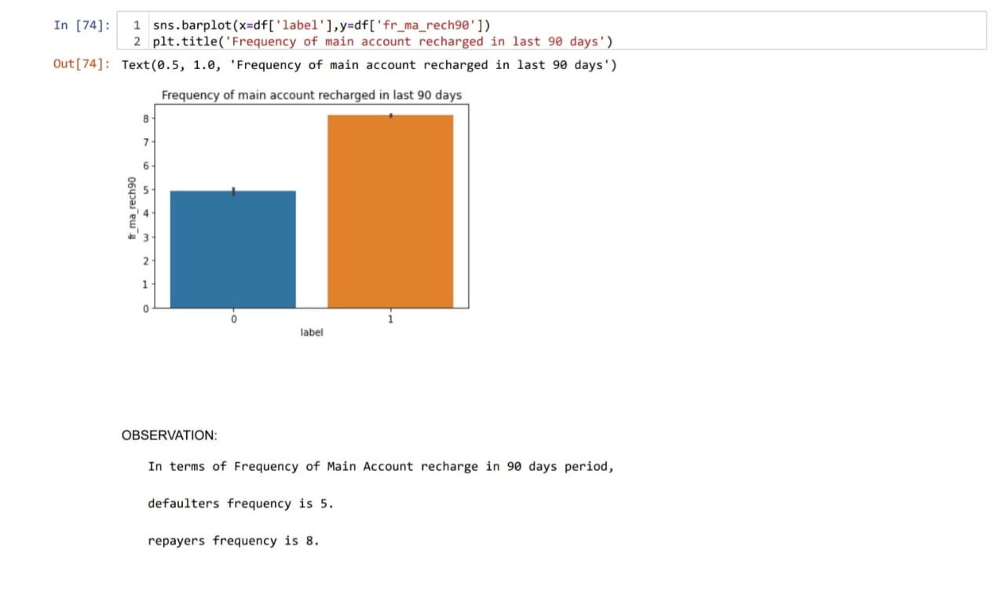

**CHECKING FOR OUTLIERS:**

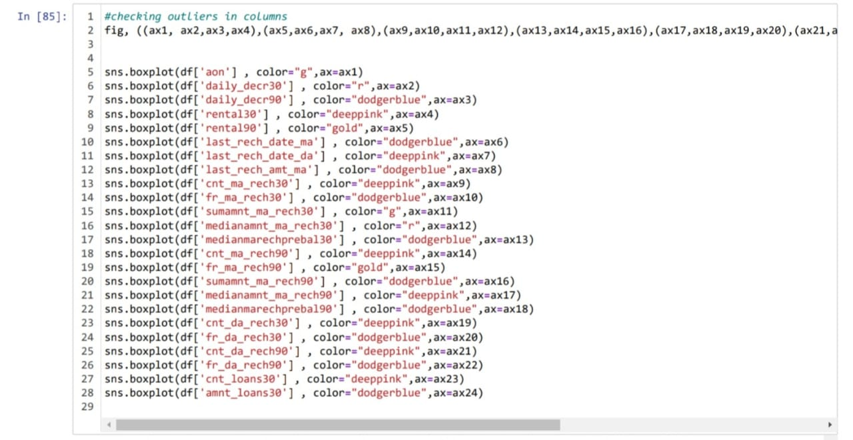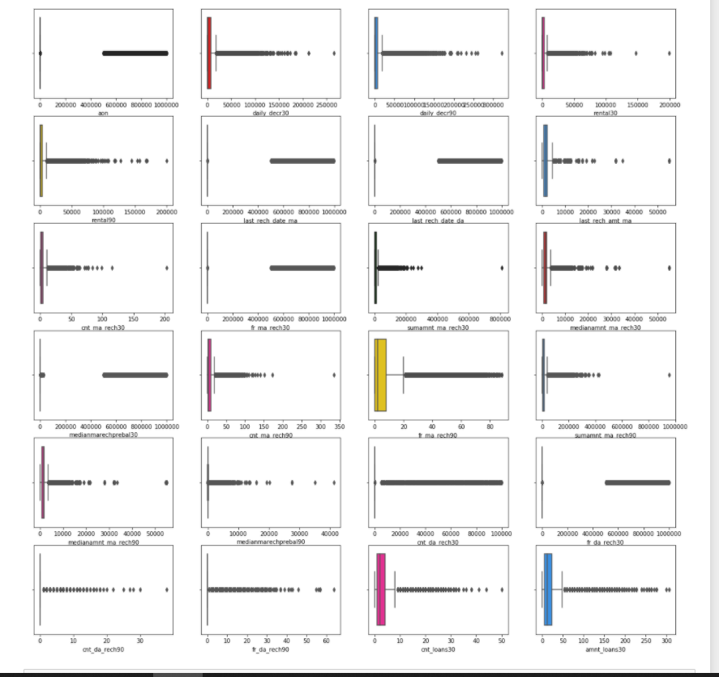

**Interpretation of the Results:**

* We can note that there is less data about defaulters and more about those who did repay their loan. Hence can say that the data is imbalanced
* With increase in Age on Network, defaulting rate is higher.
* The data is collected based on different parameters for two time periods. One observation is for 30 days and other is for 90 days. Analyzing the parameters separately.
* **For 30 days:**

1. With the increase in Average Main balance, there is a probability of defaulting.
2. Defaulters recharged Main account max number between 1 and 2 times. Whereas re-payers recharged for 4 plus times.
3. On an average the defaulters has recharged for a max of 1000 Indonesian Rupaiah for Main Balance.
4. Defaulters has recharged the data account for a maximum of 200 to 250 times.With increase in No.of times data accounts recharge,probability of defaulting is high
5. A defaulter may default after 2 days ,repayers took average of 3.5 days.
6. Defaulters took 1 loan, re payers took 3 loans.

* **FOR 90 DAYS:**

1. the defaulters has spent a max of 1000 from main account,Repayers has spent 7000 rupaiah.
2. Defaulters average main account balance =2000 to 2500 Repayers average main account balance = 3500
3. Defaulters recharged main account for 2 times. Re-payers recharged main account for 7 times.
4. Defaulters frequency of main account recharge is 5, Re-payers frequency of main account recharge is 8.

**CONCLUSION**

* **Key Findings and Conclusions of the Study**:

The defaulting rate is higher in old customers. Defaulters recharge for the main account less no.of times but does recharge for data account more no.of times.

Re payers recharge the main account more no.of times when compared to defaulters.

* **Learning Outcomes of the Study in respect of Data Science**

One of the challenge i faced while data cleaning is outlier removal, in most of the scenarios Z-score will be used as outlier removal technique since it performs quite well with less data loss. In our data set, Z-score has caused 22% data loss. Then I tried another famous technique called InterQuartileRange it caused around 80% data loss.

Another technique is replacing the outlier data with mean or median. But when we observe this data set there is a huge difference between minimum and maximum values. If we calculate mean or median it won’t give appropriate values as it includes the outlier value (maximum ones).So not using this approach.

As we are not dropping the outliers, another approach is capping or winsorisation of outliers. Using percentile capping. Values that are less than the value at 10th percentile are replaced by 10th percentile value, and the value greater than 90th percentile are replaced by 90th percentile value.

The other challenge is when I used the imbalanced data, the accuracy was very high but there was bias in predictions. So I used imblearn to reduce the imbalances in the target variable.

**Limitations of this work and Scope for Future Work:**

This data set contains data of the year 2016 belonging to psw telecom circle.

If we get data of other years along with other telecom companies we can predict on varied scenarios.